**Name – Ashish Mukherjee**

**Class – LY NS**

**Batch – A**

**ASSIGNMENT - 6**

**AIM** – Install and use Zabbix for monitoring diverse IT components, including networks, servers.

**THEORY -**

Zabbix is a network management tool, which is used to monitor the network traffic and network devices.

Zabbix provide various features like.

1. Displays Global View of network
2. Displays Host Inventory of network
3. Displays User Groups on network
4. Generating a report regarding notifications.
5. Generates Audit Logs
6. 100 busiest triggers report
7. Availability Report

**INSTALLATION STEPS**

1.Choose your platform on which you want to install zabbix, it is mostly suitable for linux ubuntu, centOS etc.

2.Install zabbix repository

# wget https://repo.zabbix.com/zabbix/6.2/ubuntu/pool/main/z/zabbix-release/zabbix-release_6.2-2%2Bubuntu22.04_all.deb  
# dpkg -i zabbix-release_6.2-2+ubuntu22.04_all.deb  
# apt update

3.Install zabbix server ,frontend,agent

# apt install zabbix-server-mysql zabbix-frontend-php zabbix-apache-conf zabbix-sql-scripts zabbix-agent

4.Install mysql on the platform

5.Create Initial Database

# mysql -uroot -p  
password  
mysql> create database zabbix character set utf8mb4 collate utf8mb4_bin;  
mysql> create user zabbix@localhost identified by 'password';  
mysql> grant all privileges on zabbix.* to zabbix@localhost;  
mysql> set global log_bin_trust_function_creators = 1;  
mysql> quit;

6. On Zabbix server host import initial schema and data. You will be prompted to enter your newly created password.

# zcat /usr/share/zabbix-sql-scripts/mysql/server.sql.gz | mysql --default-character-set=utf8mb4 -uzabbix -p zabbix

7. Disable log_bin_trust_function_creators option after importing database schema.

# mysql -uroot -p  
password  
mysql> set global log_bin_trust_function_creators = 0;  
mysql> quit;

8.Configure the database for zabbix server. Edit file /etc/zabbix/zabbix_server.conf

DBPassword=password

9.Start Zabbix Server and Agent Processes

# systemctl restart zabbix-server zabbix-agent apache2  
# systemctl enable zabbix-server zabbix-agent apache2

OUTPUTS

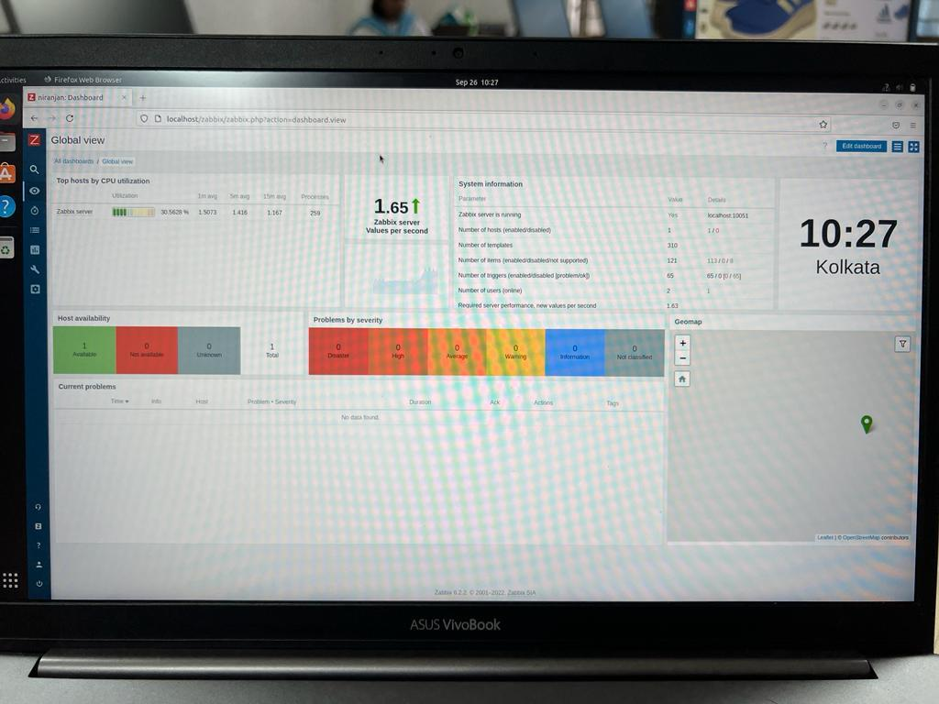 GLOBAL VIEW

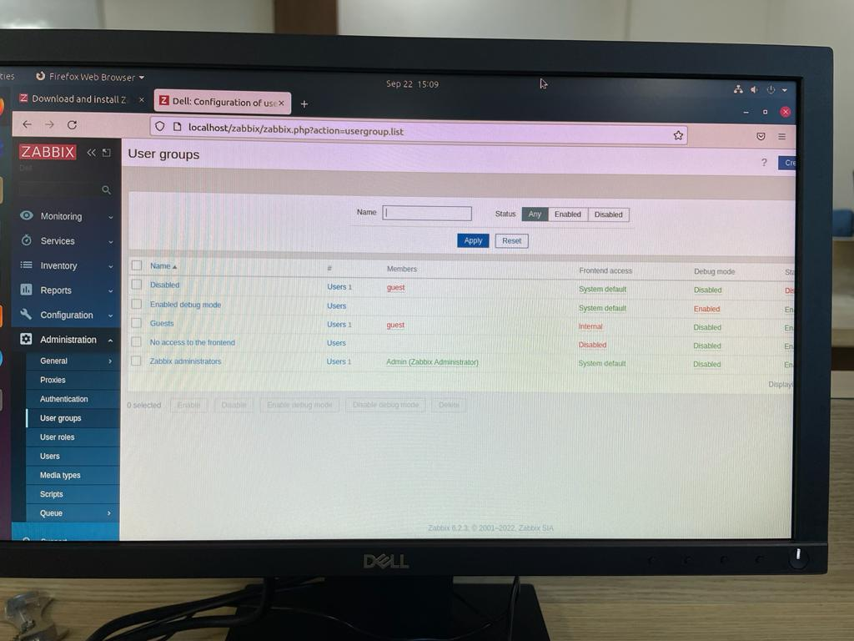 USER GROUPS

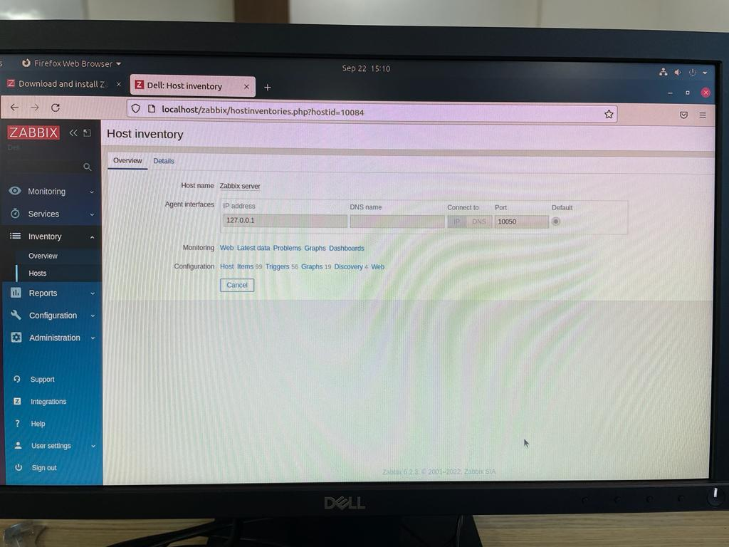 HOST INVENTORY

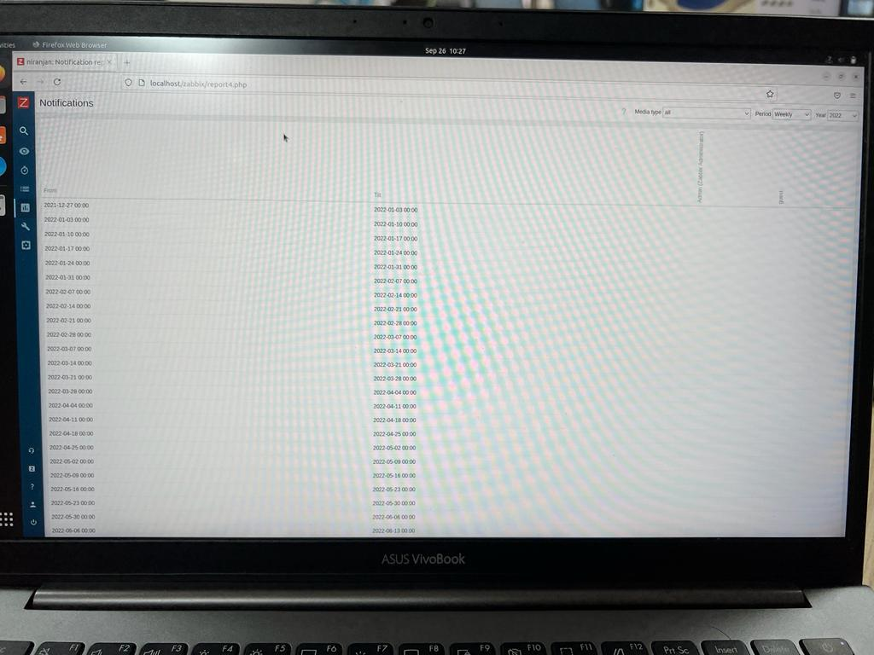 NOTIFICATIONS

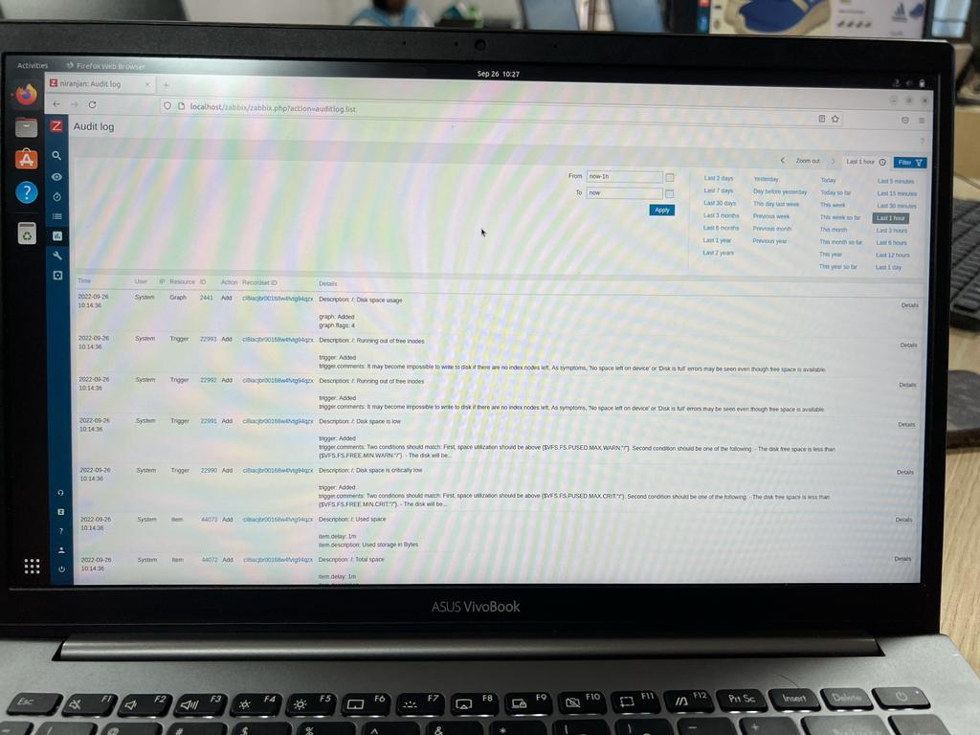 AUDIT LOG

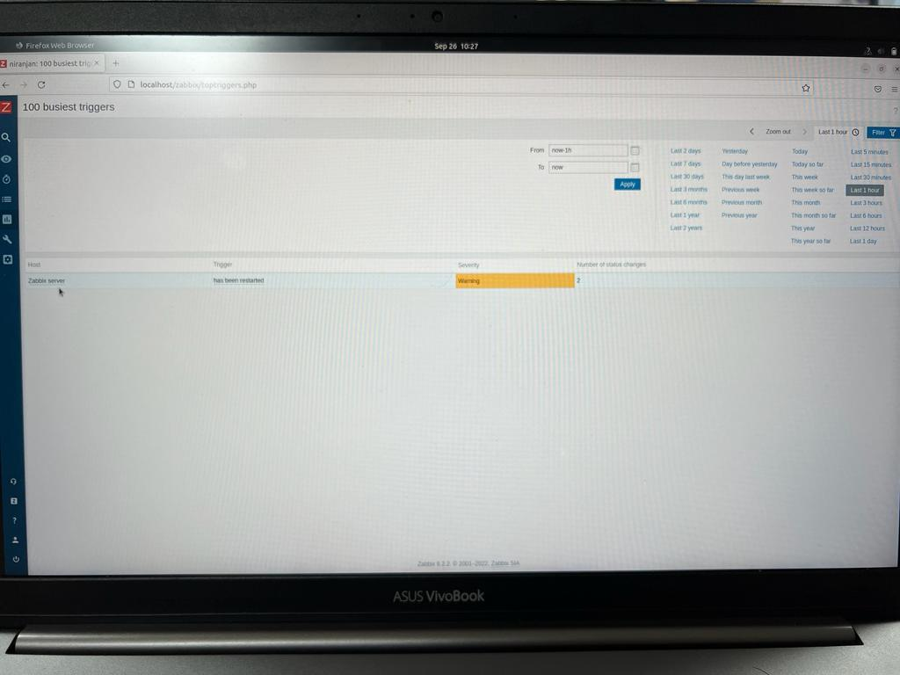 100 BUSIEST TRIGGERS

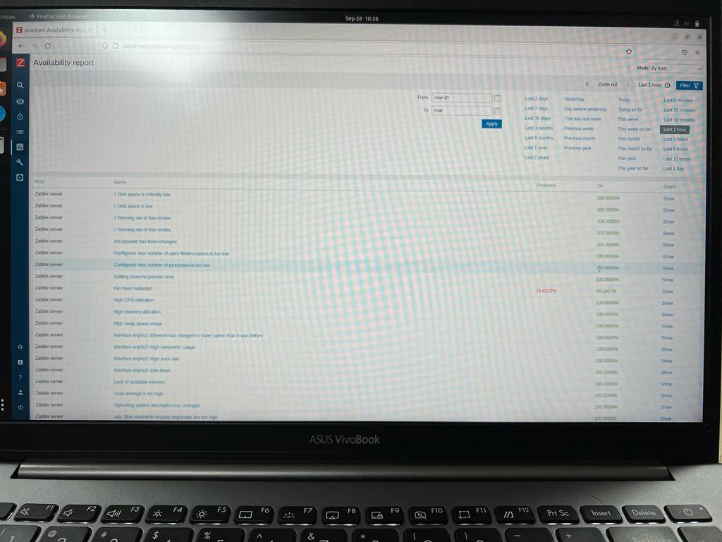 AVAILABILITY REPORT

**Conclusion**

**We were able to successfully install the Zabbix network management tool , and also monitored the network, Reports were generated on the basis of needs.**